// 1 Code

<!DOCTYPE html>

<html lang="en">

<head>

<meta charset="UTF-8">

<meta name="viewport" content="width=device-width, initial-scale=1.0">

<title>Alert Hello</title>

<script>

window.onload= function()

{

alert("Hello, world");

};

</script>

</head>

<body>

<h1>Welcome</h1>

</body>

</html>

**1 Output:**

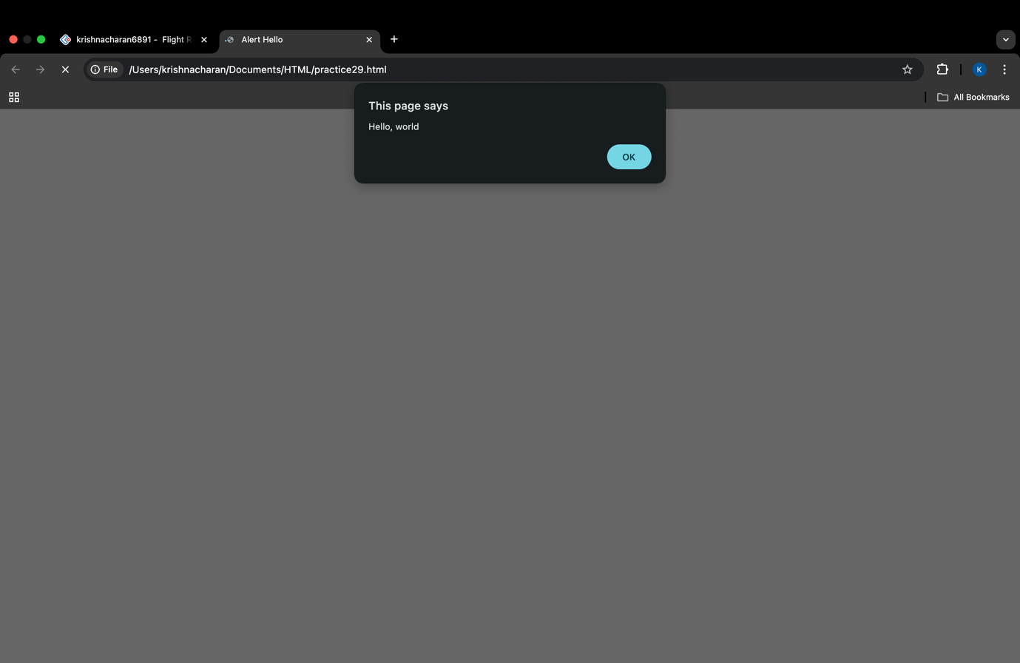

// 2a code

<!DOCTYPE html>

<html lang="en">

<head>

<meta charset="UTF-8">

<meta name="viewport" content="width=device-width, initial-scale=1.0">

<title>DOM</title>

<script>

function changetext(){

document.getElementById("myParagraph").innerText="You Clicked The Button";

}

</script>

</head>

<body>

<p id="myParagraph">This is the original paragraph</p>

<button onclick="changetext()">click me</button>

</body>

</html>

2A Output:

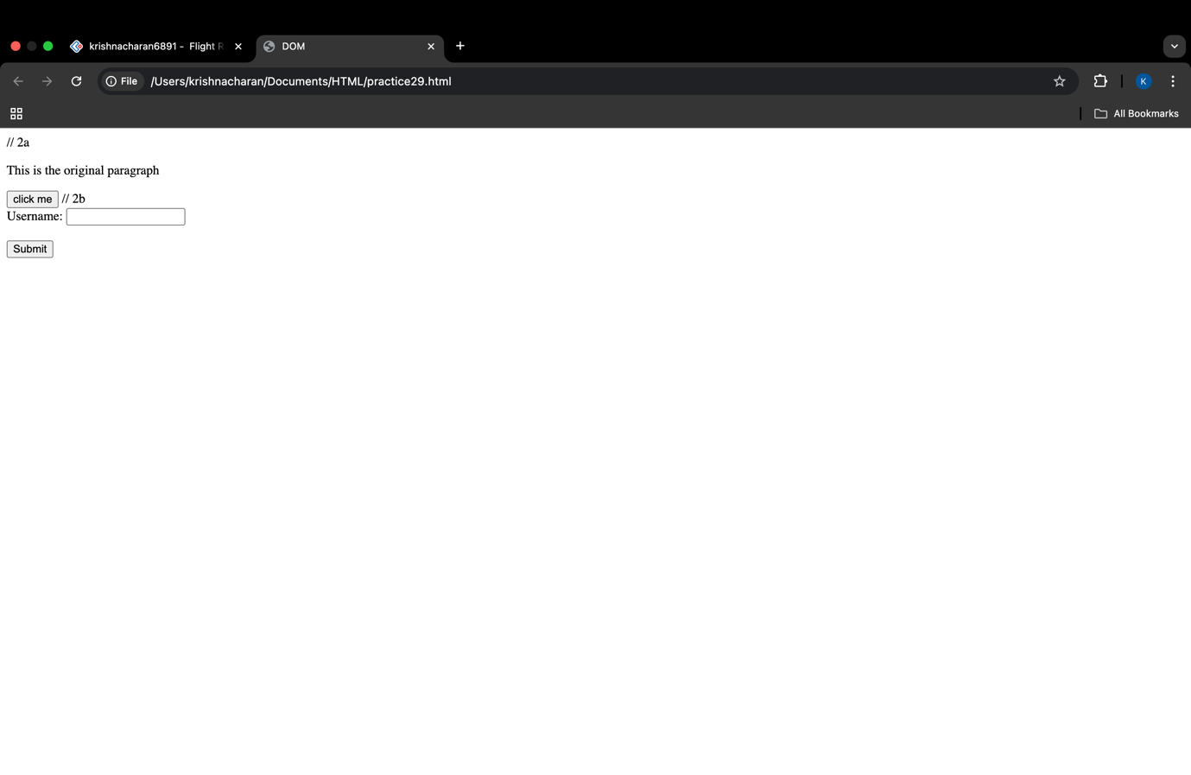

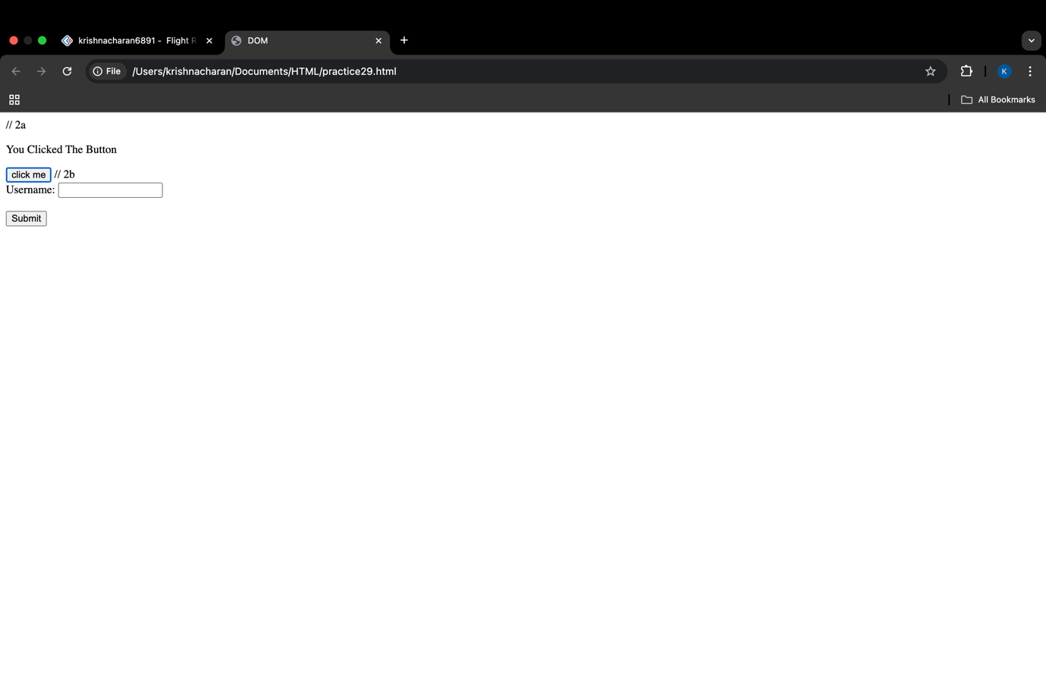

// 2b code

<!DOCTYPE html>

<html>

<head>

<title>Username Form</title>

<script>

function validateForm(event) {

var username = document.getElementById("username").value;

if (username.trim() === "") {

alert("Username is required!");

event.preventDefault();

}

}

</script>

</head>

<body>

<form onsubmit="validateForm(event)">

<label for="username">Username:</label>

<input type="text" id="username" name="username">

<br><br>

<input type="submit" value="Submit">

</form>

</body>

</html>

2B Output:

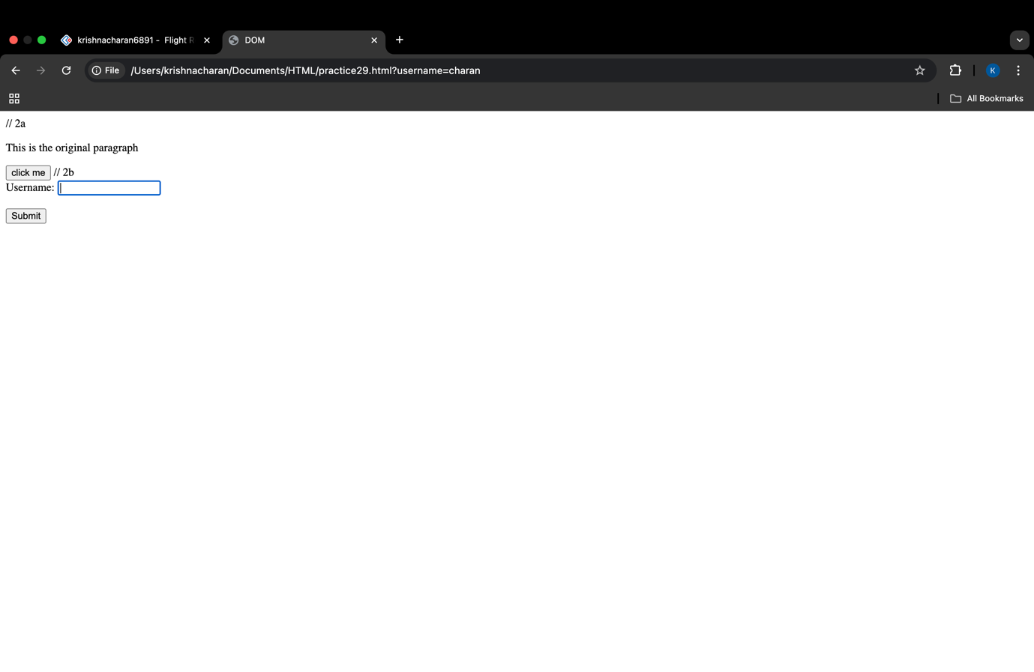

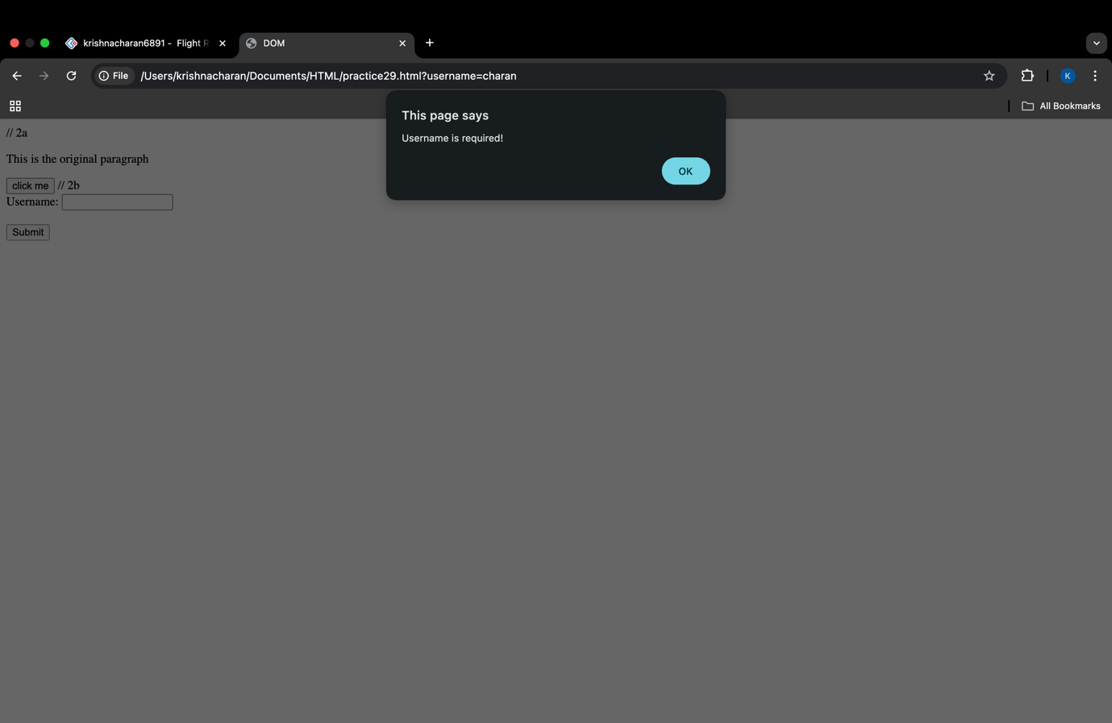

// 3a code

<!DOCTYPE html>

<html>

<head>

<title>Current Date and Time</title>

<script>

window.onload = function() {

var now = new Date();

var dateTimeString = now.toString();

document.getElementById("datetime").innerHTML = dateTimeString;

}

</script>

</head>

<body>

<h2>Current Date and Time</h2>

<div id="datetime"></div>

</body>

</html>

3A Output:

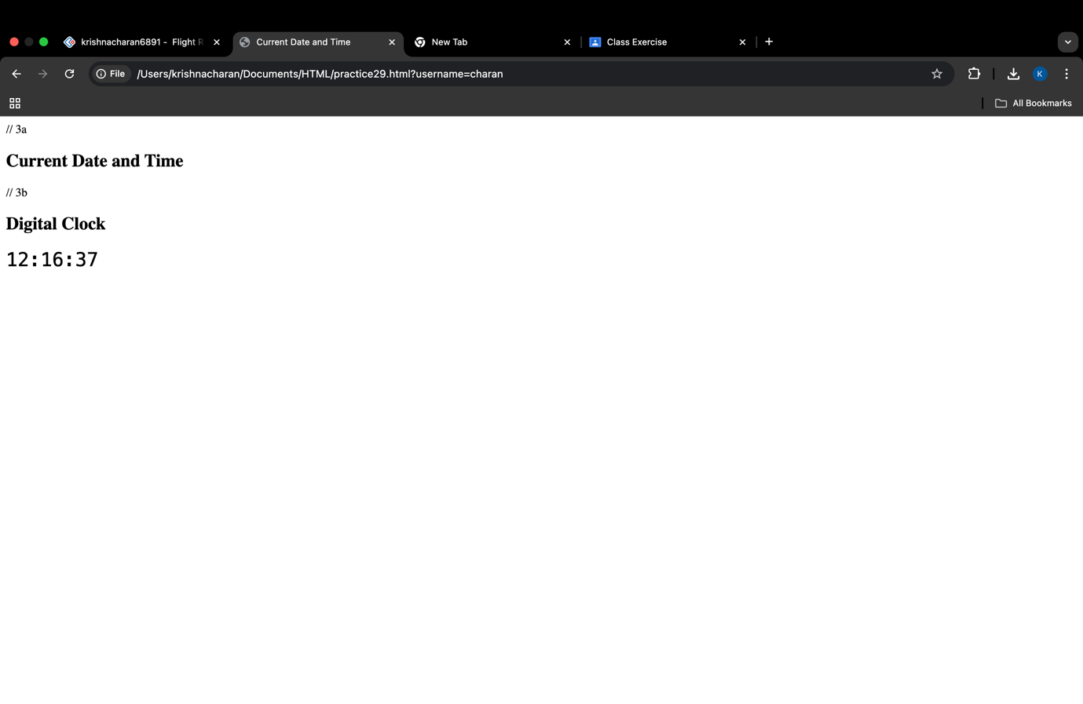

// 3b code

<!DOCTYPE html>

<html>

<head>

<title>Digital Clock</title>

<style>

#clock {

font-size: 2em;

font-family: monospace;

margin-top: 20px;

}

</style>

<script>

function updateClock() {

var now = new Date();

var hours = now.getHours().toString().padStart(2, '0');

var minutes = now.getMinutes().toString().padStart(2, '0');

var seconds = now.getSeconds().toString().padStart(2, '0');

var timeString = hours + ":" + minutes + ":" + seconds;

document.getElementById("clock").innerHTML = timeString;

}

window.onload = function() {

updateClock();

setInterval(updateClock, 1000);

}

</script>

</head>

<body>

<h2>Digital Clock</h2>

<div id="clock"></div>

</body>

</html>

3B output:



// 4 code

<!DOCTYPE html>

<head>

<title>Email Validation Form</title>

<script>

function validateEmail(event) {

var email = document.getElementById("email").value;

var emailPattern = /^[a-zA-Z0-9]+@[a-zA-Z0-9]+\.[a-zA-Z]{2,}$/;

if (!emailPattern.test(email)) {

alert("Please enter a valid email address");

event.preventDefault();

}

}

</script>

</head>

<body>

<h2>Email Validation Form</h2>

<form onsubmit="validateEmail(event)">

<label for="email">Email:</label>

<input type="text" id="email" name="email">

<br><br>

<input type="submit" value="Submit">

</form>

</body>

</html>

4 Output:

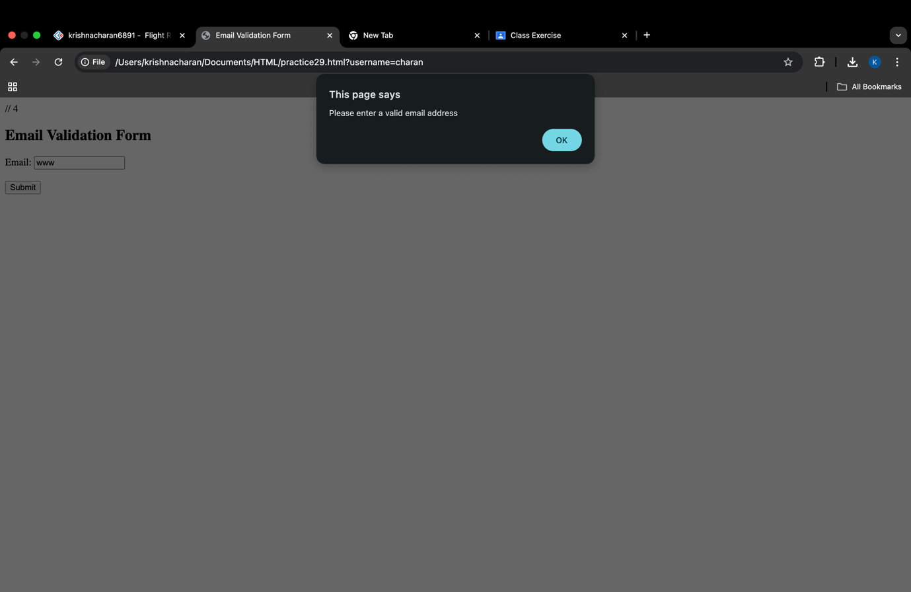

// 5a code

<!doctype html>

<html>

<head>

<script>

function changeColor() {

var e = document.getElementById('hover');

e.style.backgroundColor = 'lightcoral';

}

function revertColor() {

var e = document.getElementById('hover');

e.style.backgroundColor = 'green'; // Revert to original color when mouse leaves

}

</script>

</head>

<body>

<div id="hover"

onmouseover="changeColor()"

onmouseout="revertColor()"

style="background-color:green;height:200px;width:200px;">

</div>

</body>

</html>

5A output:

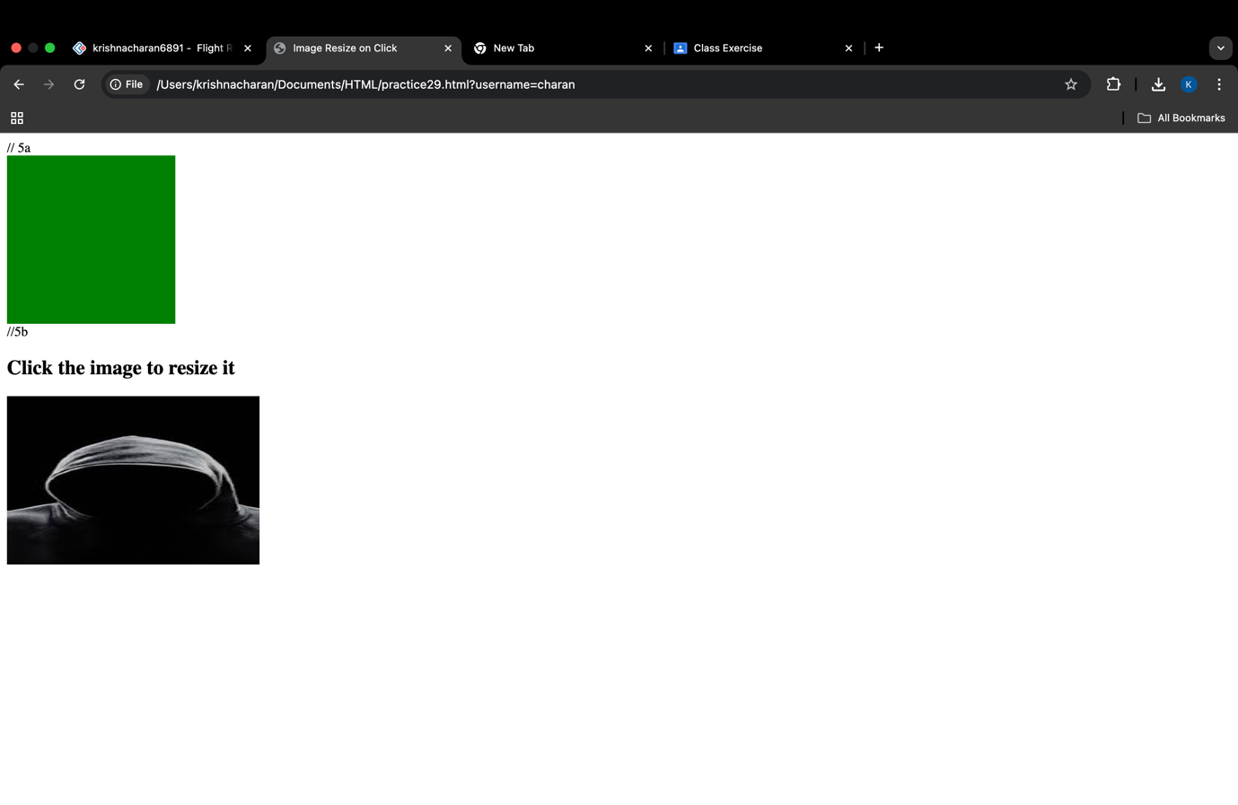

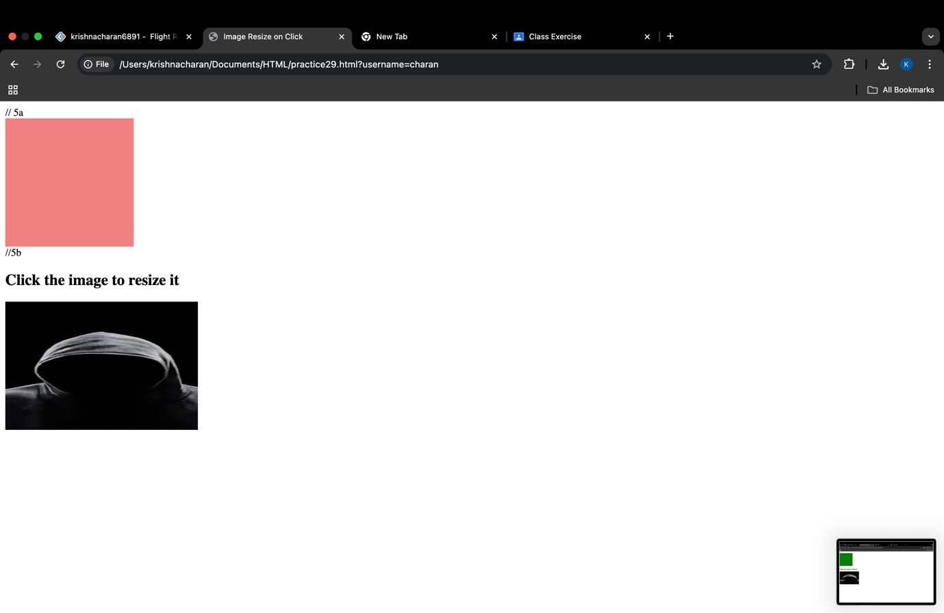

//5b code

<!DOCTYPE html>

<html lang="en">

<head>

<meta charset="UTF-8">

<meta name="viewport" content="width=device-width, initial-scale=1.0">

<title>Image Resize on Click</title>

<style>

#image {

width: 300px;

height: 200px;

transition: width 0.5s, height 0.5s; /* Smooth transition for resizing */

}

</style>

<script>

function resizeImage() {

var img = document.getElementById("image");

// Toggle between two sizes

if (img.style.width === "600px") {

img.style.width = "300px";

img.style.height = "200px";

} else {

img.style.width = "600px";

img.style.height = "400px";

}

}

</script>

</head>

<body>

<h2>Click the image to resize it</h2>

<img id="image" src="hacker.jpeg" alt="hacker" onclick="resizeImage()">

</body>

</html>

5B output:

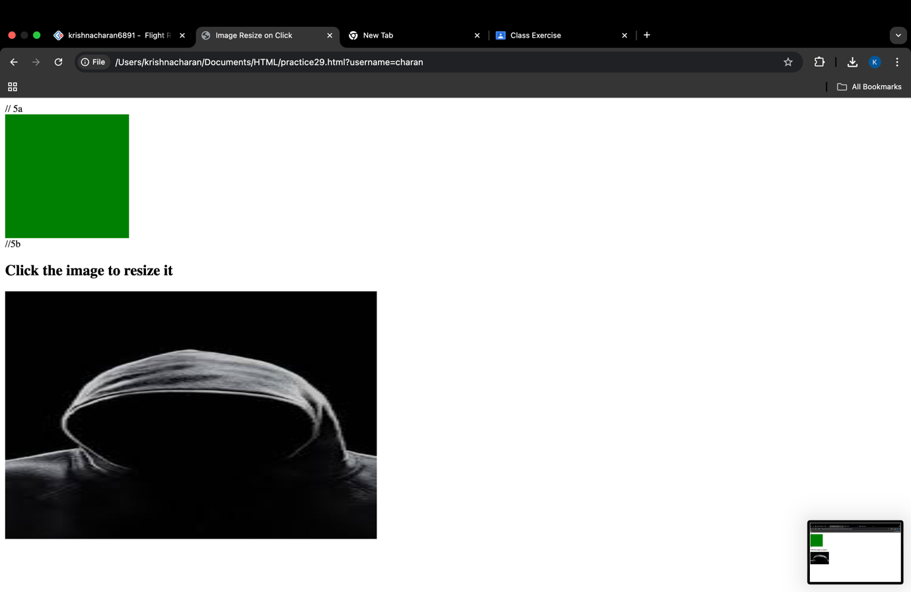

// 6 code

<html>

<head>

<script type="text/javascript">

function divideNumbers() {

try {

var num1 = 10;

var num2 = 5;

if (num2 === 0) {

throw "Cannot divide by zero!";

}

var result = num1 / num2;

alert("Result is: " + result);

} catch (error) {

alert(error);

}

}

</script>

</head>

<body>

<p>Click the following to attempt division:</p>

<form>

<input type="button" value="Divide Numbers" onclick="divideNumbers();" />

</form>

</body>

</html>

6 Output:

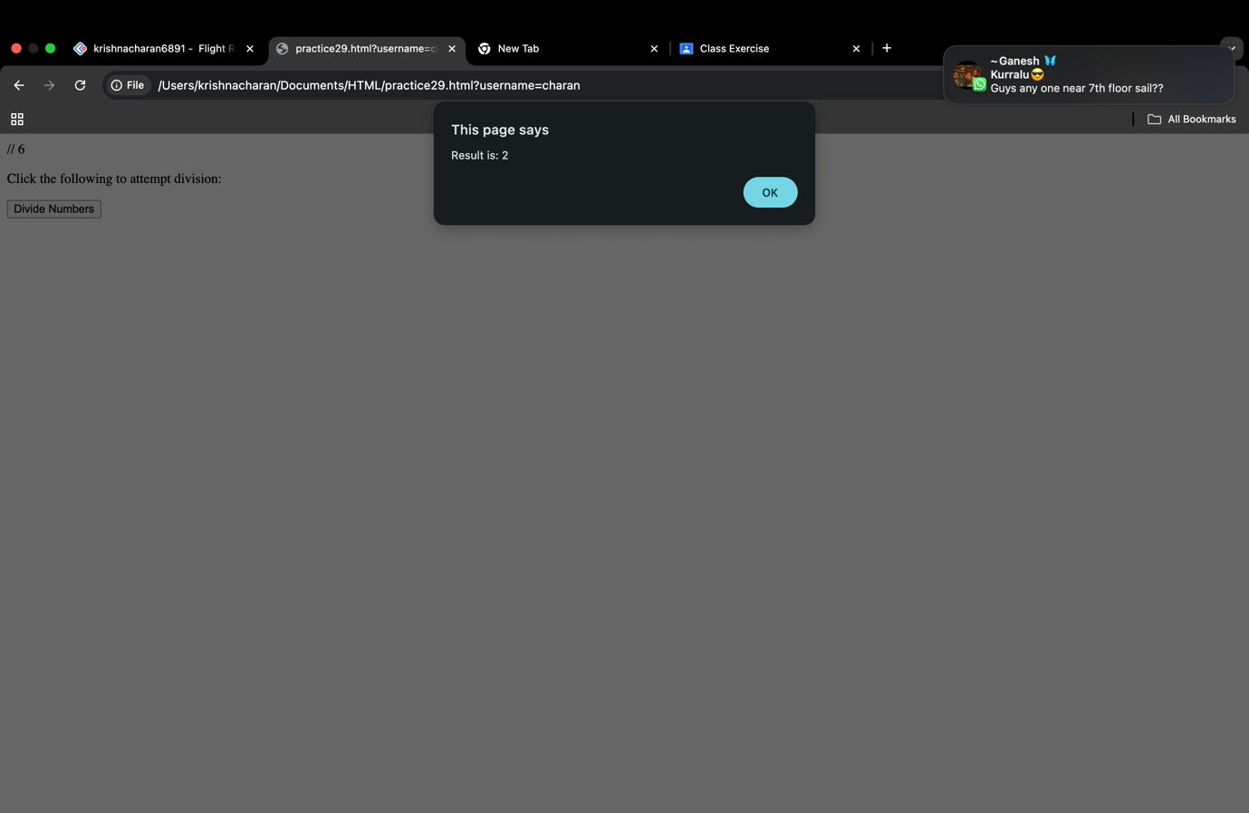

// 7 code

<!DOCTYPE html>

<html lang="en">

<head>

<meta charset="UTF-8">

<meta name="viewport" content="width=device-width, initial-scale=1.0">

<title>Square Root Calculator</title>

<script type="text/javascript">

function calculateSquareRoot() {

var number = document.getElementById("number").value;

var result = Math.sqrt(number);

document.getElementById("result").innerHTML = "The square root is: " + result;

}

</script>

</head>

<body>

<h2>Square Root Calculator</h2>

<p>Enter a number:</p>

<input type="number" id="number" />

<input type="button" value="Calculate Square Root" onclick="calculateSquareRoot()" />

<p id="result"></p>

</body>

</html>

7 Output:

